WE ARE ON A MISSION
“Through advocacy, education and empowerment, the DisAbility Ministries Committee of the United Methodist Church will lead the denomination in creating a culture where people with disabilities are fully included in all aspects of worship, leadership and ministry.”
“LOVE what you all are doing! GREAT stuff!" Amy Fenton Lee

WHO WE ARE
- two members per jurisdiction
- liaison members from related organizations
- resource people
Most of us have disabilities and others have children with disabilities. All of us are passionate about making churches accessible, welcoming, and hospitable!
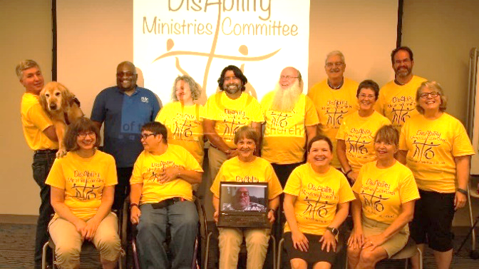
WE OFFER
- A website filled with resources
- A quarterly e-mail newsletter
- News sent out through Facebook, Twitter, Pinterest
- Disability Awareness Sunday materials
- Accessibility audit tools; accessibility visits to camps, churches, and agencies
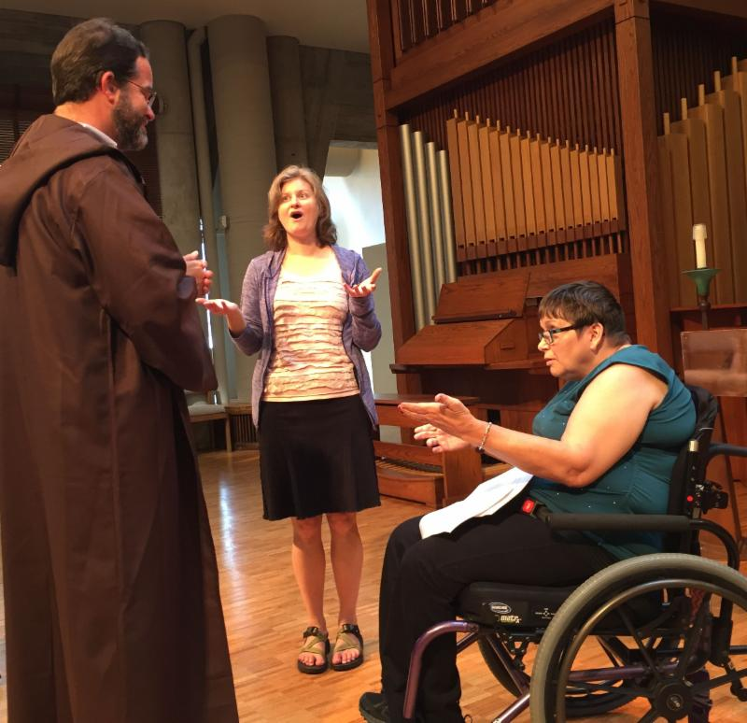
- New models of ministry
“I regularly cite your committee and its work as one of the best examples of denominational work in this area in the United States. Your newsletter is probably the best one around…. You all have helped develop materials that others use.” Bill Gaventa, M.Div.
- Workshops/training
- Networking and advocacy
- Connections within your jurisdiction
- Resource people available to serve you
“It was amazing to me…how relatively simple it is to make spaces more accessible for people.” Rev. Douglas Clement

- Prayer for your ministry
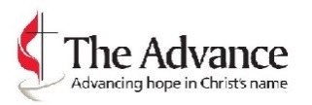
SUPPORT THIS WORK!
#3021054 Disability Ministry
https://www.umcmission.org/Give-to-Mission/Search-for-Projects/Projects/3021054
Your gifts provide funding for the committee’s work, with a focus on grants, resources, and other help for congregations working to become more accessible and welcoming to people with disabilities.
PARTNERS IN MINISTRY
United Methodist Committee on Deaf and Hard of Hearing Ministries: www.umcdhm.org
United Methodist Association of Ministers with Disabilities: www.umdisabledministers.org
Your Conference Disability Committee: www.umdisabilityministries.org/ links/acgroup.html
Mental Health Ministries:
www.mentalhealthministries.net

MAKING PATHS STRAIGHT— REMOVING BARRIERS

Isaiah 40: 3-4
“A voice cries out: ‘In the wilderness prepare the way of the LORD, make straight in the desert a highway for our God. Every valley shall be lifted up, and every mountain and hill be made low; the uneven ground shall become level, and the rough places a plain.’”

Is your church facing challenges that you need help with? Maybe you have members who have autism, wounded veterans returning home, or people with Alzheimer’s or low vision in your congregation. Maybe you would like to start a disability/accessibility team.
We are here to help you remove the barriers!
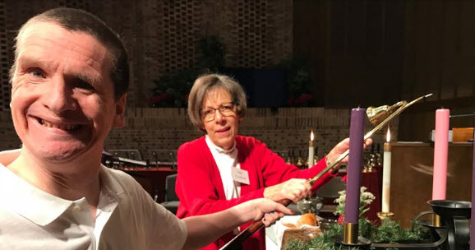
CONNECT WITH US
www.UMDisAbilityMinistries.org
E-mail: UMdisability@gmail.com
On Facebook:
DisAbility Ministries Committee of The United Methodist Church
On Twitter and on Pinterest: UMDisability
CONTACT US
- To let us celebrate and publicize your ministry, workshop, or program
- To share your gifts and strengths to assist with the work of the Committee
- To ask questions and find the tools you need to move forward with your ministry
- To help you grow an effective disability committee per ¶653 of The Book of Discipline of the United Methodist Church 2016
Making Paths Straight
Removing Barriers
